- Click on FNOL from mega menu
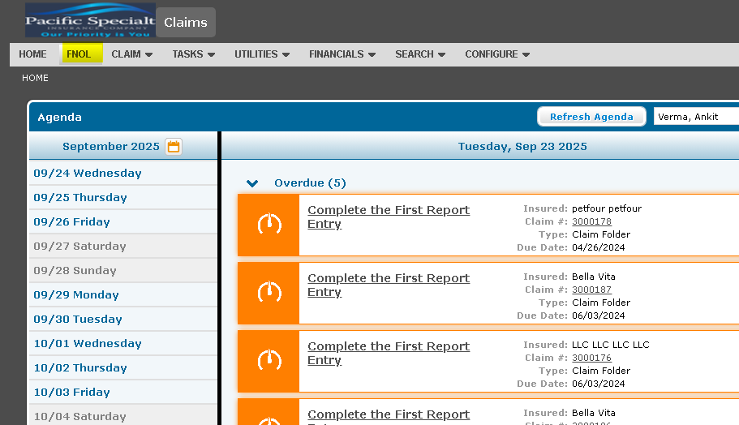

- Select Date of Loss and click on continue
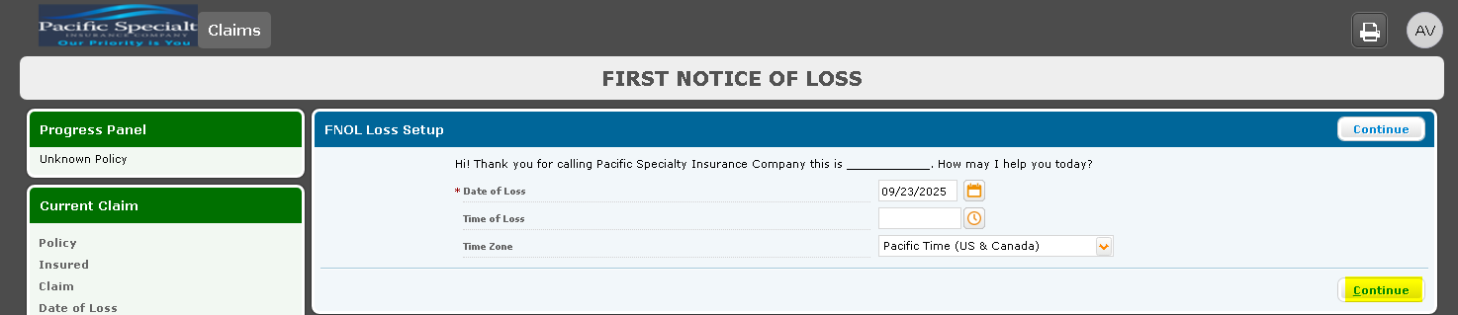

- Provide the policy number and click on search, the system will search for policy.
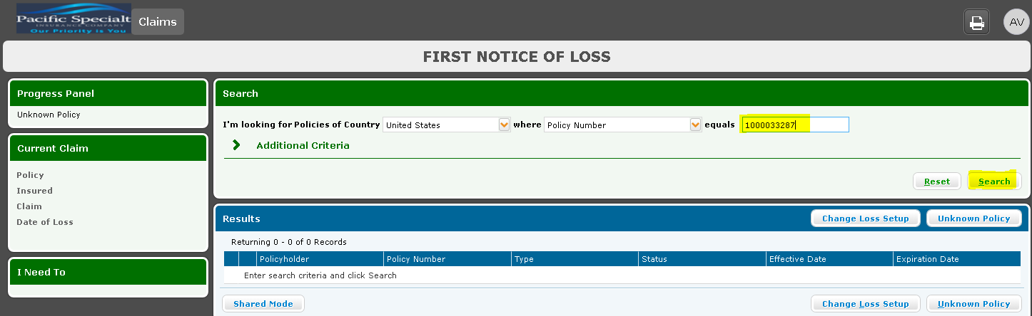

- Once the policy details appear click continue, the system will attach the policy.
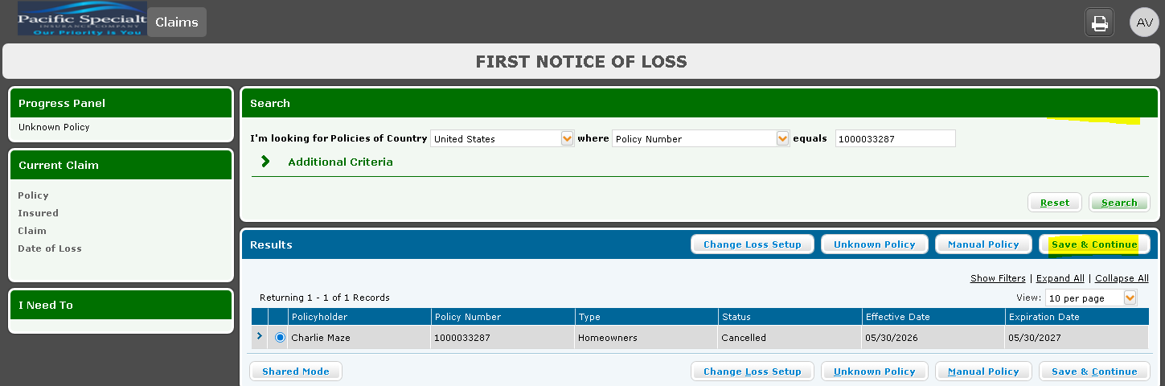

- Once the policy is attached, verify the policy details, Scroll down to items and select covered and involved and click continue.
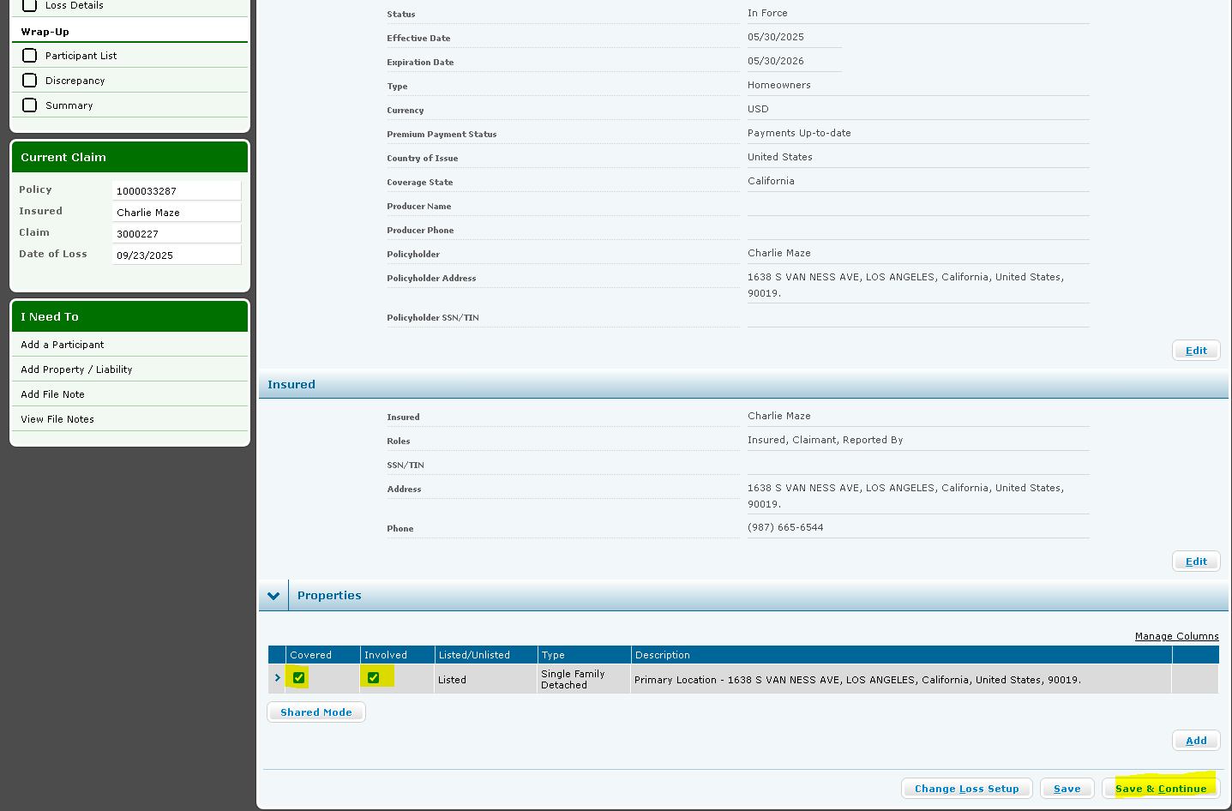

- Loss details page, add the required loss details and click continue
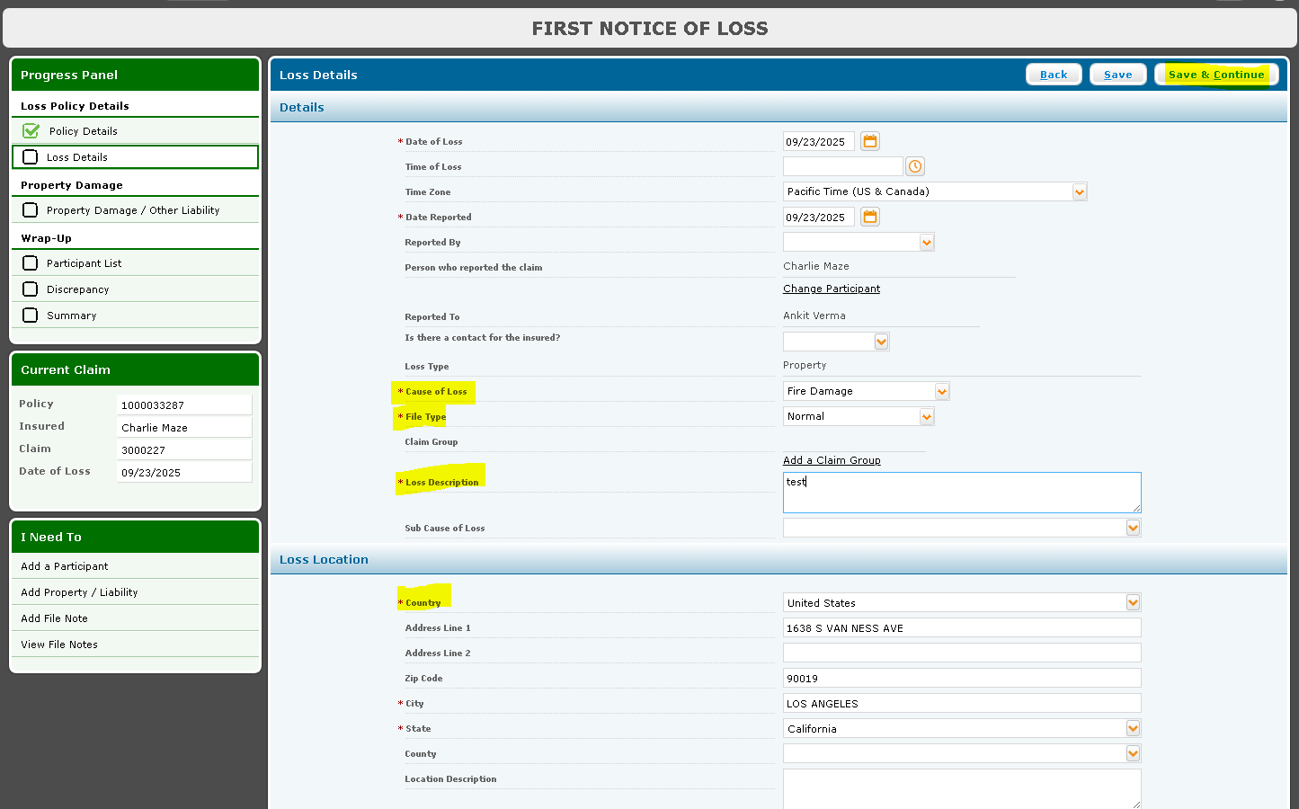

- Keyfacts page, provide the required details on the page and click continue
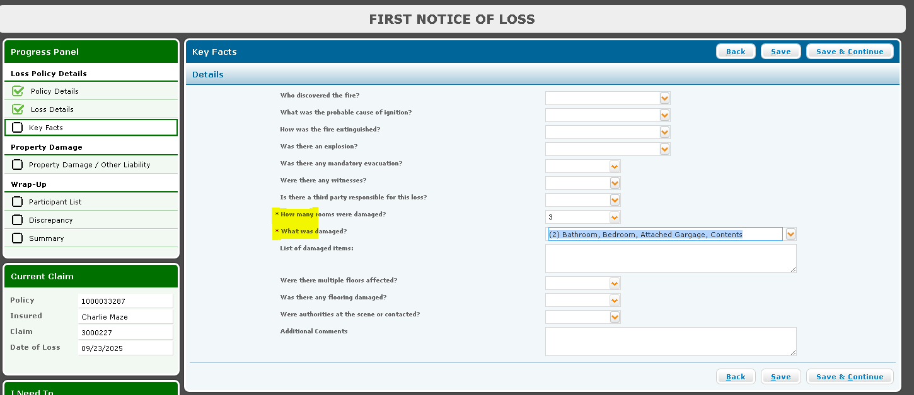

- Click save and continue to move to Property Damage page and provide required details for property damage.
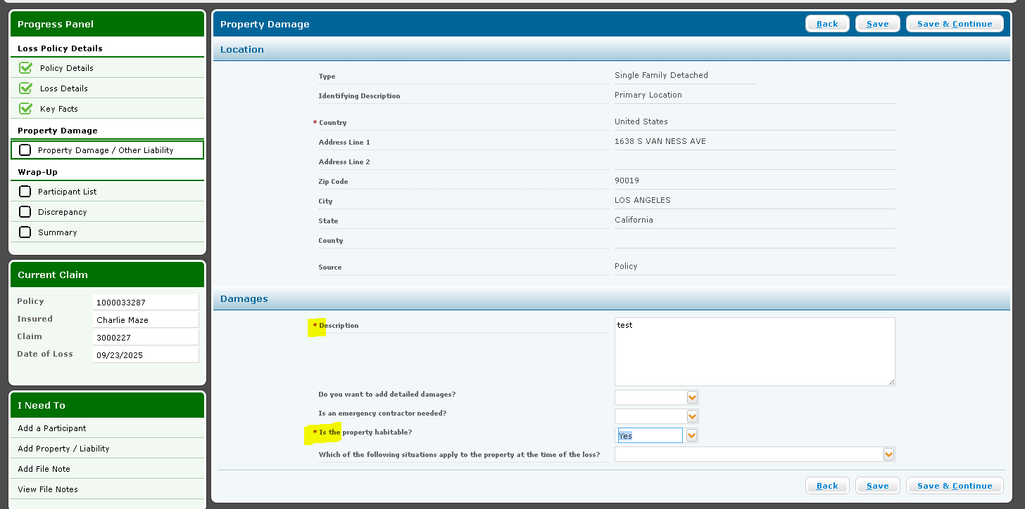

- Participant List Page, lists all the participants that came from policy. Make sure claimant is present on the list.
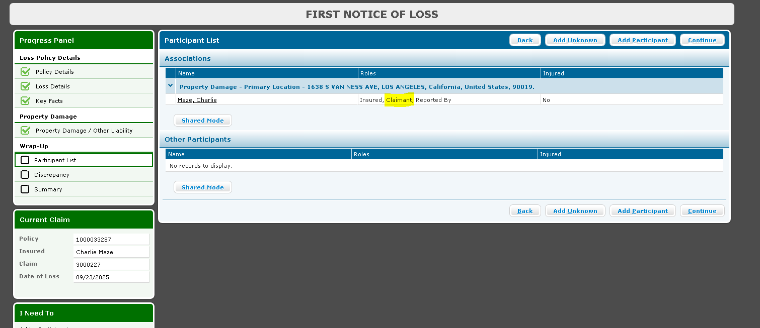

- Discrepancy Page, Click continue of all the resolution required value is no, if it is yes then click on the field and provide the value
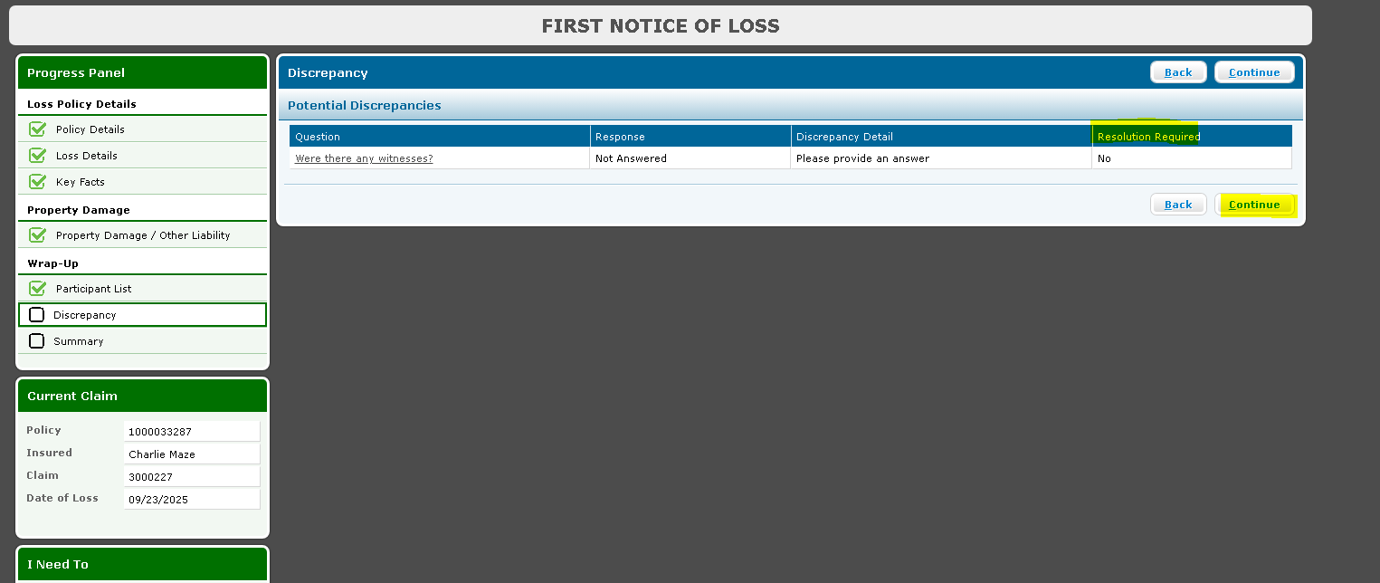

- Claim Summary Page, verify the details and click on continue.
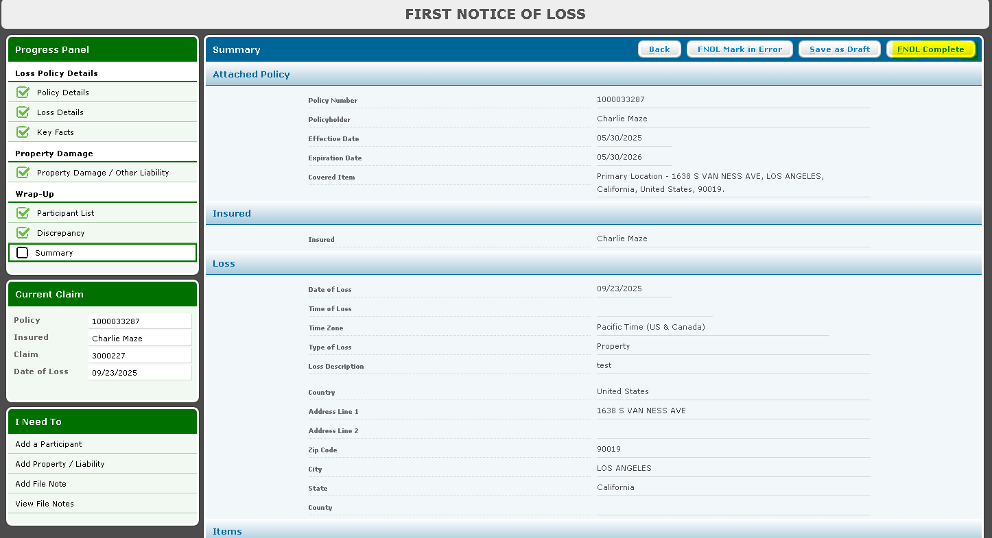

- Wait for the claim number link to activate and claim owner details appear.
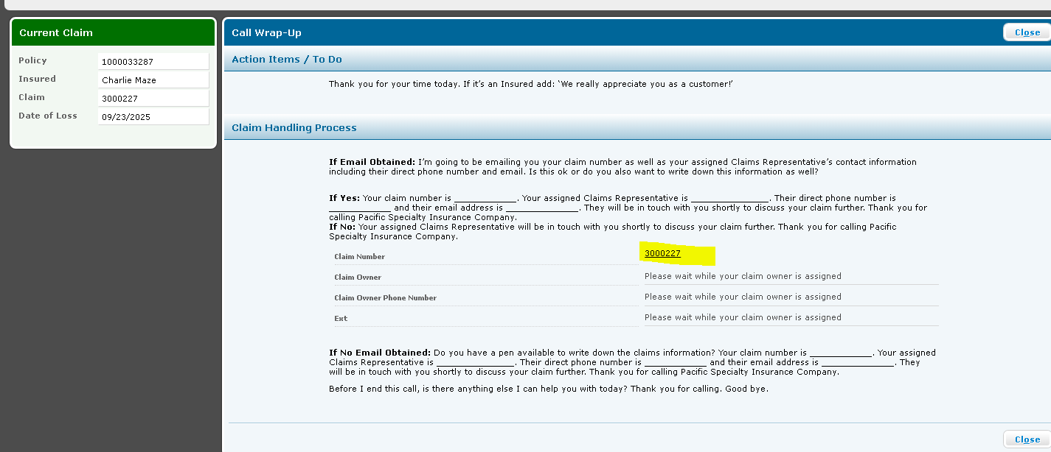
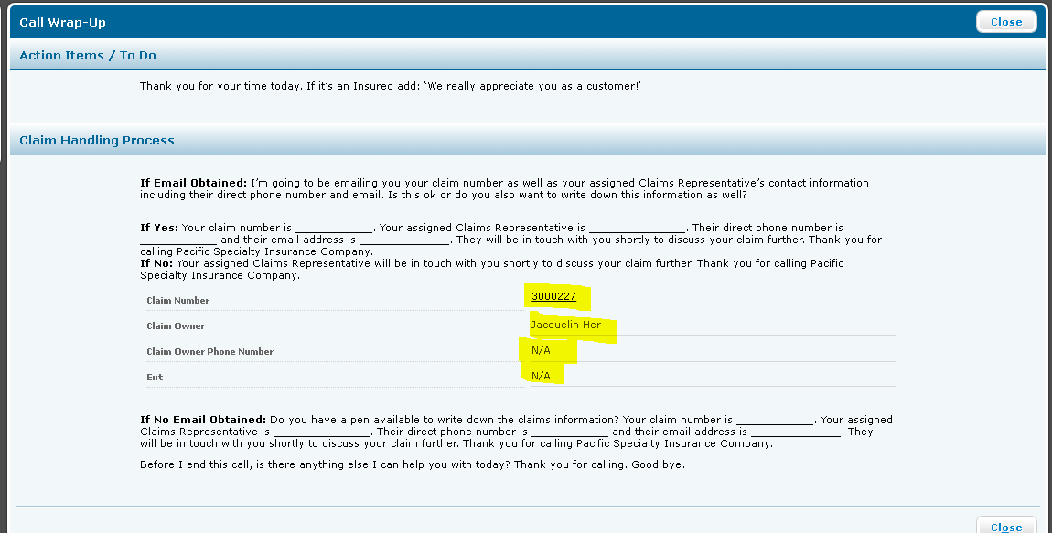
- Click on the claim number and open the claim. The claim is created.
